Task 1

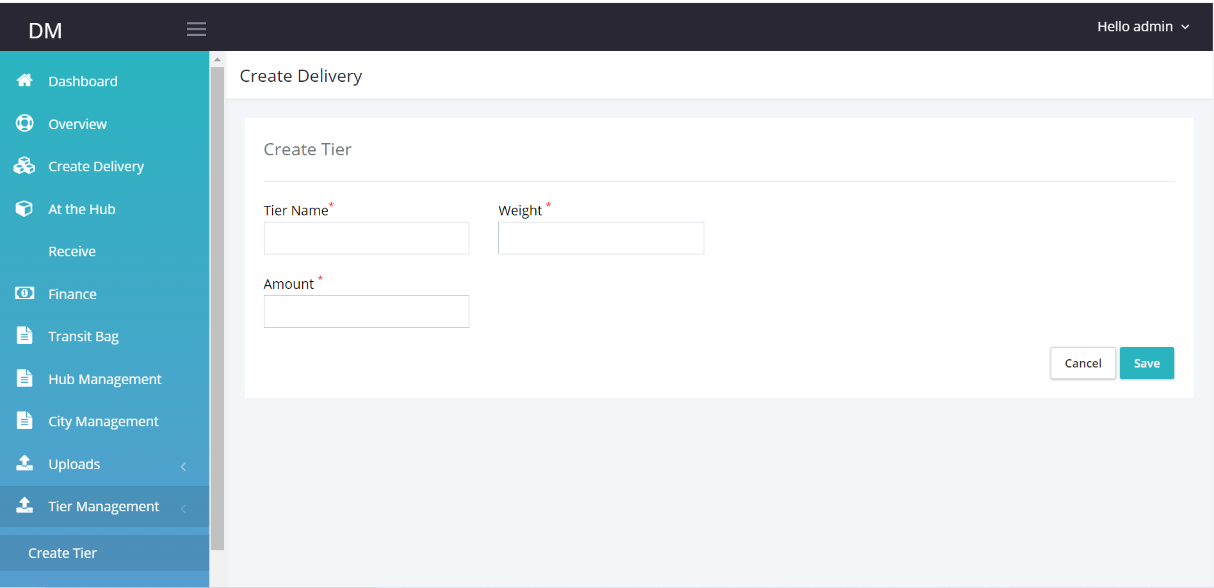

Create Tier Tab: This tab currently does not work.

Make tab accept inputs and store data in the data base.

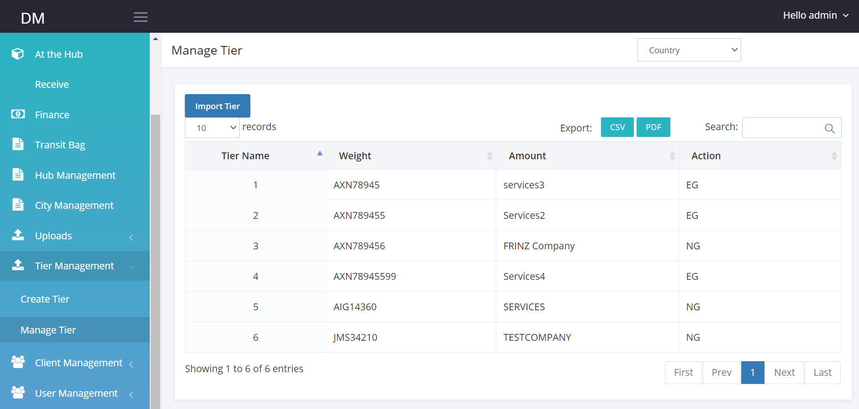

Edit

Edit

Edit

**Manage Tier:** Enable tier management.

When Tier is created using the tier Tab, I should see all tiers on the manage tier table.

I should be able to edit each listing.

Import Tier should allow me import tier data.

Zone Management

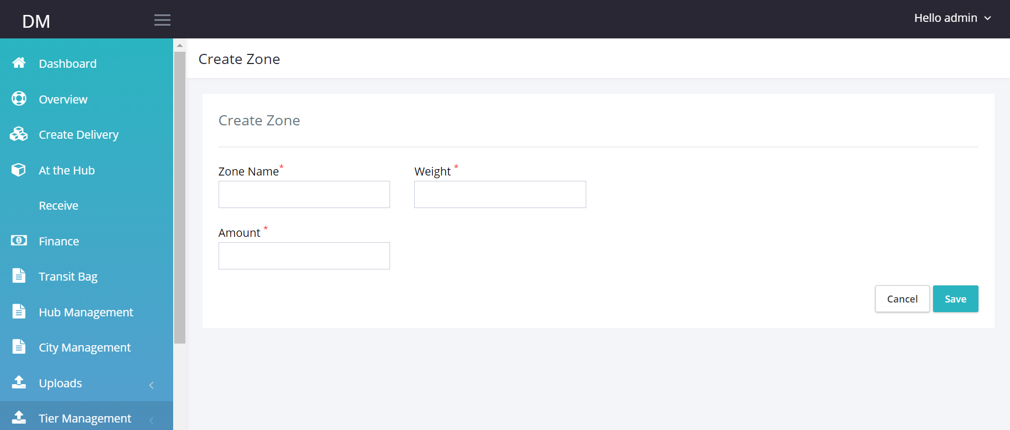

**Create Zone:**  Make zone page receive and store data.

**Manage Zone:**

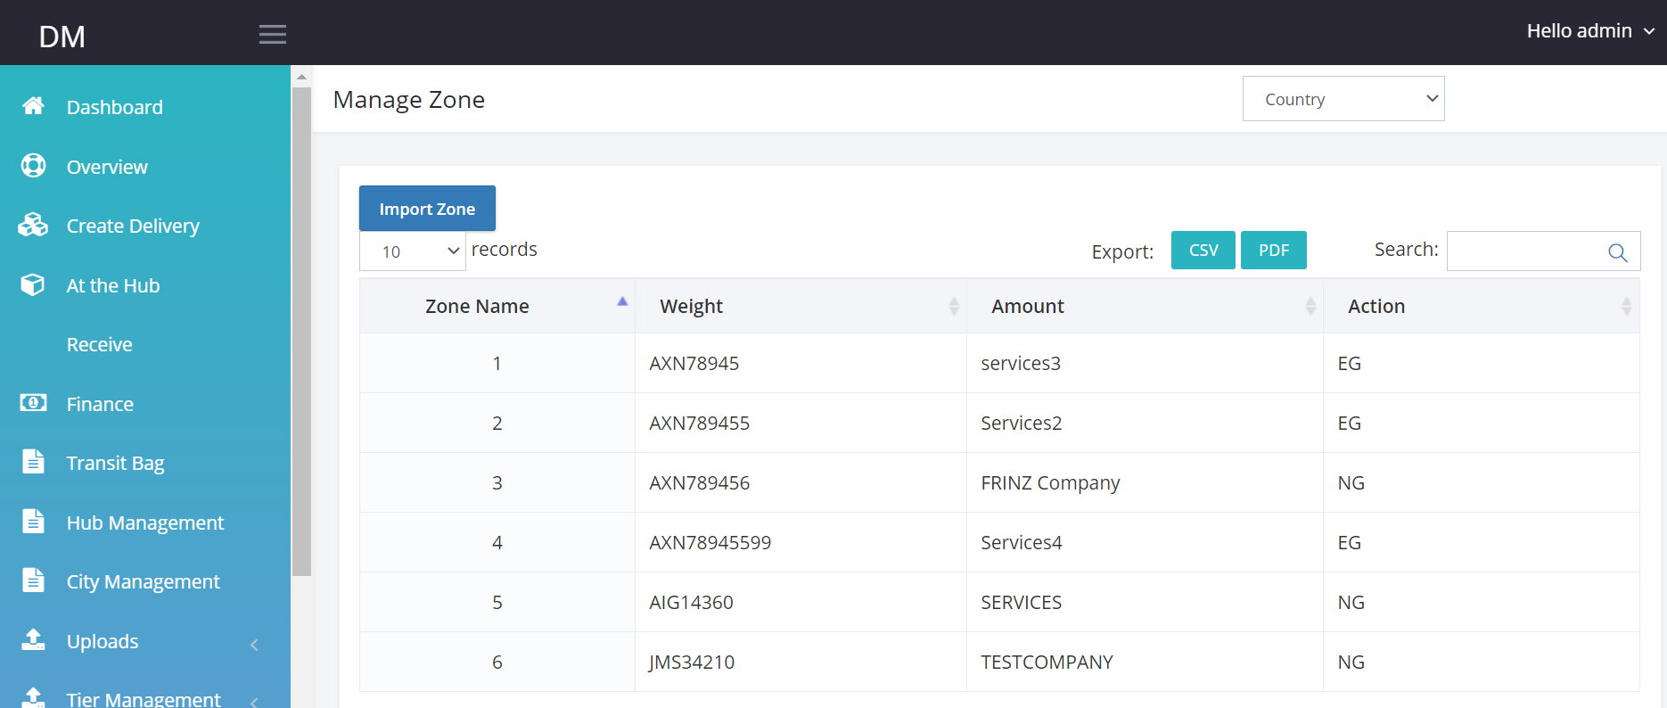

Edit

* Enable data from Zone table visible on manage zone tab
* Import Zone: I should be able to import new zone data or update zone data using csv.

Edit

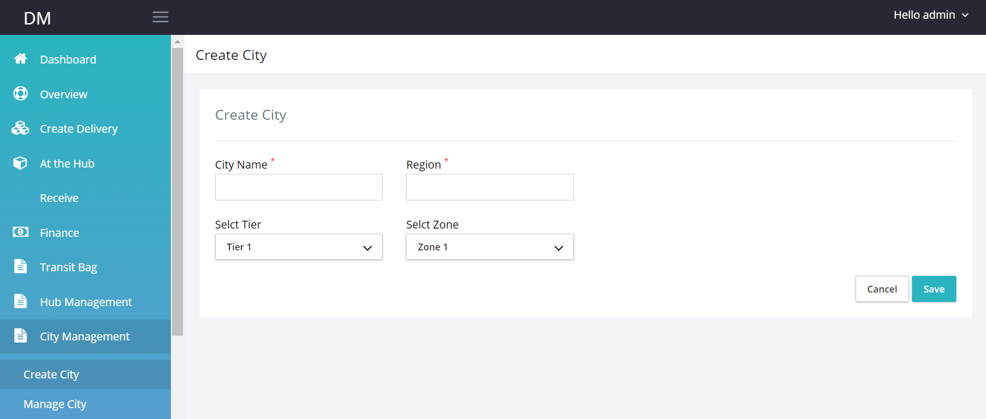

**Create City Tab:** Add city tab to the menu.

Make input boxes work.

Select Tier: This should be from available data on tier management table-should be searchable box

Select Zone: This should be from the available data on Zone management Table should be searchable box.

**Manage City Tab**

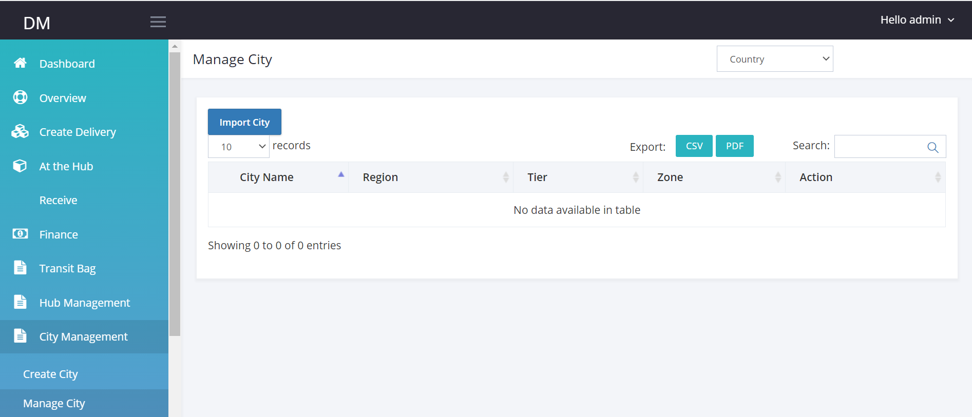

Edit

I should be able to view all Created city Data from Manage city

When I click edit I should be able to edit cities.

Hub Management.

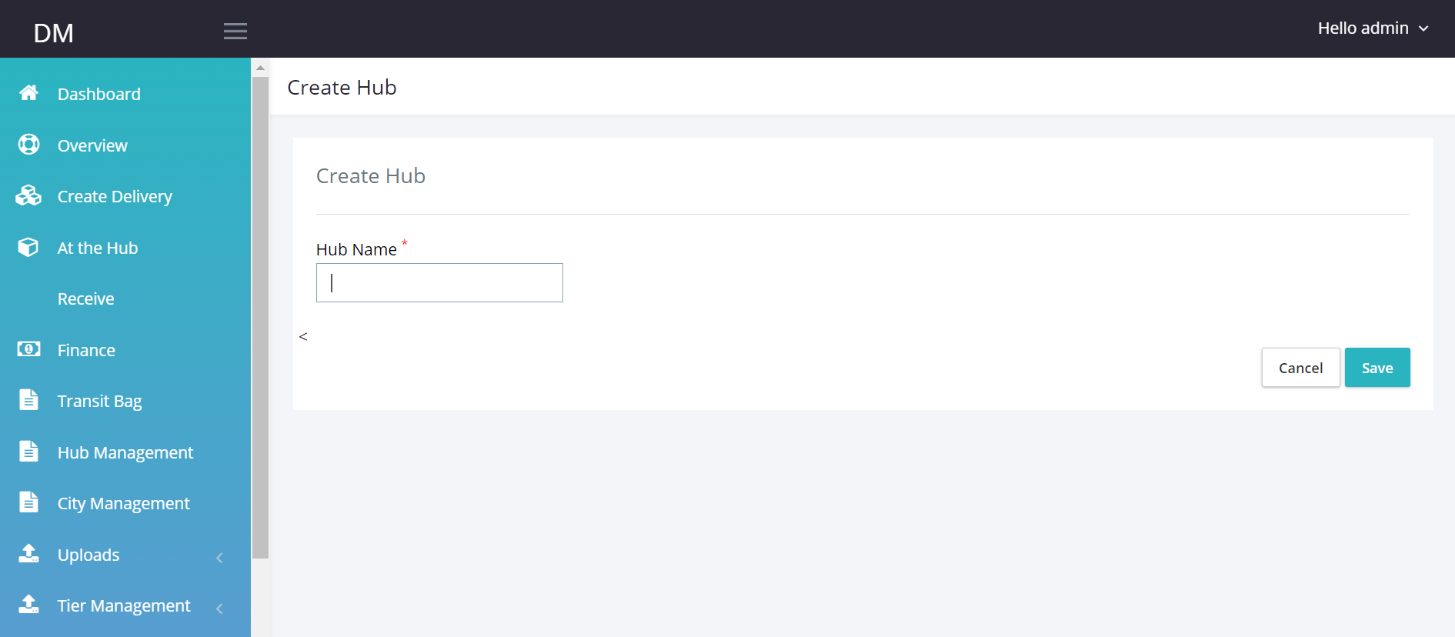

Create Hub

Manage hub

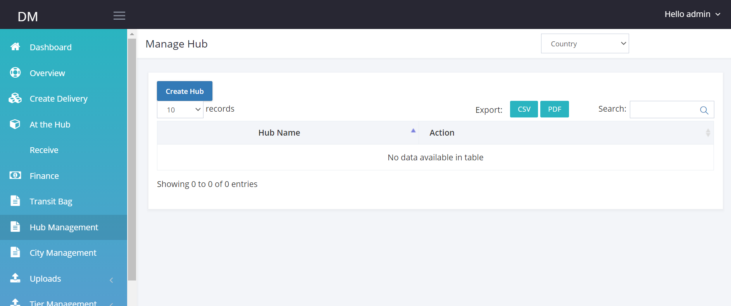

**Task 3**

**Create Delivery**

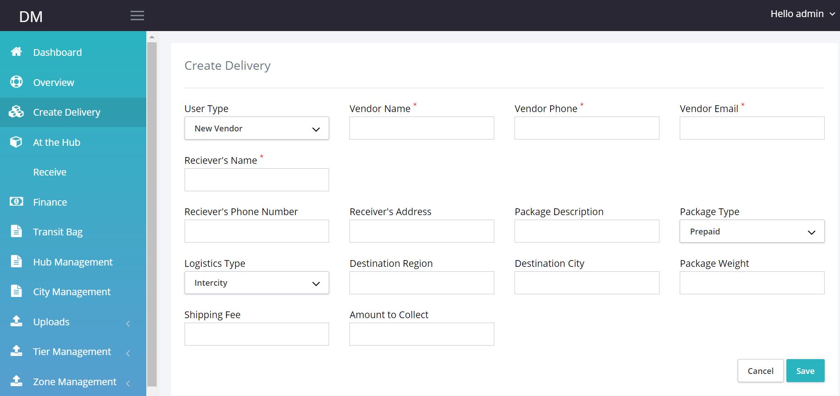

Link the tab to a database.

**User Type:** If user clicks New Vendor, Vendor Name, Vendor Phone and Vendor’s email should be visible and data entered on these field should create new entry on vendor table as well.

If User type already exists, user should be able to select vendor name from the list of available vendors and every other vendor field is populated.

Destination City: This should be selected from available city.

Shipping fee: Check selected City, check inputted weight, add tier and zone amount.

Origin Hub: list of hubs.

Once submit display PDF document ( 2 pages) Invoice and waybill, Then store in pending table

Tracking number is auto generated.

Package status becomes pending.

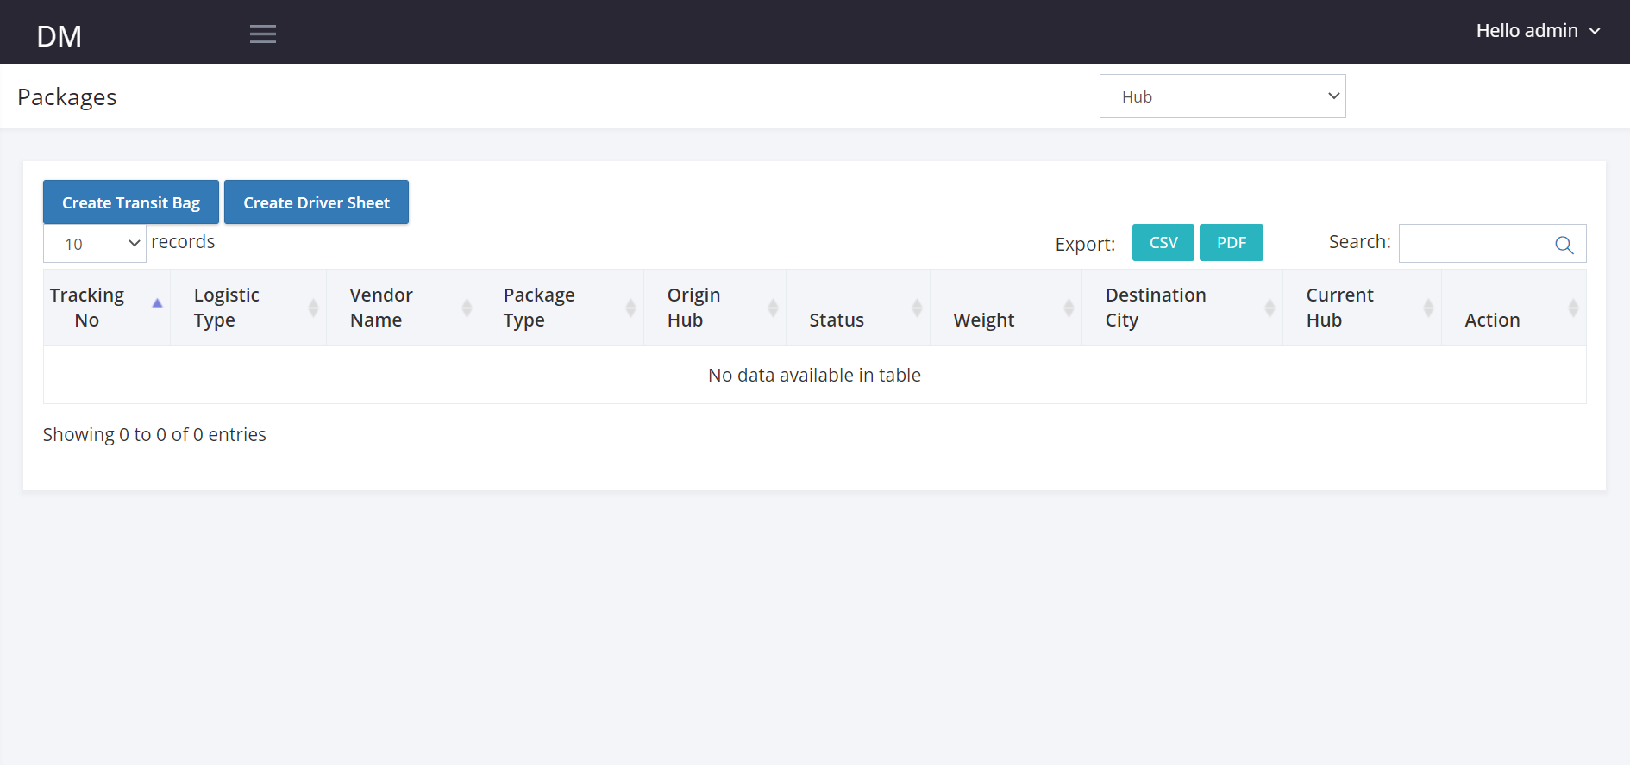

**Receiver’s Name:** Test Test Shipping Fee: Created At

Receiver’s Phone: Amount to Collect: Updated by:

Receiver’s Address: Transit Bag Number: Updated By:

Package Description: Created By:



1045672 Inter-city vendor1 prepaid Hub 1 Pending 2kg Lagos

When I click on the Tracking number, I should see that drop down page.